Northeast US expansions may face underutilization

Some 18 Bcf/d to 20 Bcf/d of new Northeast gas takeaway capacity expected to start up in the next several years, that should be good news for a market that has been pushing for more options to move Marcellus and Utica shale output to power plants and LNG export terminals in the Southeast.
But producers aren't lifting the volumes of gas needed to fill those pipelines and expansions, having only recently stepped up drilling after taking their foot off the pedal as prices fell to multi-year lows. That means that many of those lines face underutilization and won't be filled to their capacity with new production until at least 2019, according to data compiled by Platts Analytics' Bentek Energy that was released at an industry conference Monday in Boston .
"This mismatch between new capacity and production will only continue," Luke Jackson, a senior energy analyst at S&P Global Platts, said at the LDC Gas Forums Northeast conference.
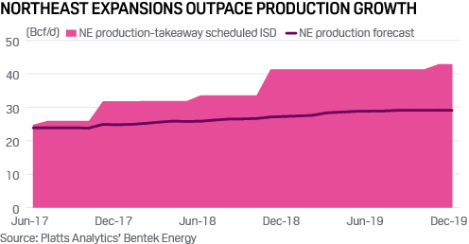...
While the markets have long looked to infrastructure expansions to leverage the Northeast region's untapped growth potential, producers backing those expansions have more modest growth outlooks than in the past.
Historically, expansions entering service were met by a quick rise in production to fill that incremental capacity. Examples of this include past east-to-west growth projects on Rockies Express Pipeline and backhaul expansion projects on Texas Eastern Transmission and Tennessee Gas Pipeline.
This time around, however, producers are growing more within their means. Producers such as Range Resources and Antero Resources, which are subscribed to forthcoming expansion projects such as Energy Transfer Partners' 3.25-Bcf/d Rover Pipeline project and the 1.5-Bcf/d Leach XPress project on Columbia Gas Transmission, are currently producing near their full-year 2017 guidance targets, indicating there may not be much upside to production in the near term. Rather, the production takeaway expansions are expected to support the companies' multi-year growth plans.
The most pronounced effects of the expansions when they do enter service will be to effectively raise gas prices in the region.
Hub pricing sees impact
Pricing at supply hubs such as Dominion South has traded at a significant discount to benchmark Henry Hub due to a substantial mismatch between supply and demand in the region. While demand can easily exceed 30 Bcf/d in the region on cold winter days, for much of the year demand falls below the region's production, which has recently notched up to around 24 Bcf/d.
As a result, pipelines receiving production such as Dominion and Texas Eastern have seen significant capacity constraints, as existing infrastructure is flexed to accommodate the region's length and move it to downstream markets. The inability for gas to move freely to where it's needed results in a discount on that gas ' value.
The in-service of projects like Rover and Leach XPress will add significant capacity to the region, which is expected to alleviate infrastructure constraints, putting a higher value on upstream gas as it can more viably flow to the downstream markets that value it highest.
Power sector watching gas dynamics
The balance between Northeast gas supply and demand is intertwined with the power sector, which counts gas as a key plant fuel.
A report issued June 2 by S&P Global Ratings assessed whether regulatory changes, specifically the Trump administration's planned withdrawal from the Paris climate pact, could impact the market trends of late. The report concluded that cheap gas will keep flowing and there isn't expected to be any major shift in how the US uses power. Gas -fired generators have seen their fates driven by shifting economics in the US rather than by regulation.
"There are opportunities for growth in the natural gas industry, but also significant risks," Michael Sloan, a managing director at Fairfax, Virginia-based consulting firm ICF International who specializes in energy, said at the Boston conference.

